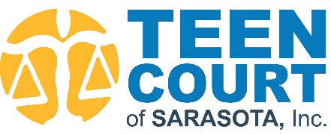 THE 2023 JACK BYERS MEMORIAL GOLF TOURNAMENT
Friday, May 12, 2023, 8:30 a.m.
Palm Aire Country Club, 5601 Country Club Way, Sarasota, FL 34243
Shotgun Sponsorship Commitment Form

Please submit this form by Friday, April 1, 2023, to receive full sponsor benefits
Sponsor Name: Click or tap here to enter text.
*Exactly as you would like it to appear on any marketing materials
Contact Name: Click or tap here to enter text.
Address: Click or tap here to enter text.
City: Click or tap here to enter text. State: Click or tap here to enter text.Zip: Click or tap here to enter text.
Phone: Click or tap here to enter text. Email: Click or tap here to enter text.

☐ Transformation $5,000 (two foursomes, signage at registration, four tee signs, opportunity to include promo material in grab bag, feature on website and social media)
☐ Positive Redirection $3,000 (one foursome, signage at shotgun, two tee signs, opportunity to include promo material in grab bag, social media recognition)
☐ Outreach $1,500 (two golfers, one tee sign, website and social media feature and opportunity to include promo material in grab bag)
☐ Succeed $500 (one golfer, one tee sign, logo on website and social media platforms)
☐ Tee Sign $150 x Click or tap here to enter text.
☐ Foursome $800 x Click or tap here to enter text.
☐ Individual Golfer $200 x Click or tap here to enter text.
I am unable to participate as a sponsor but would like to make a tax-deductible donation of $ Click or tap here to enter text.
Total enclosed $ Click or tap here to enter text. Check No. Click or tap here to enter text.
MC/VISA/AMEX Credit Card # Click or tap here to enter text. Exp. Date Click or tap here to enter text.
CVV# Click or tap here to enter text. Signature Click or tap here to enter text.
Return completed form to: Lori@SarasotaTeenCourt.org
Mail completed form to: Teen Court of Sarasota, Inc. | P.O. Box 48927 | Sarasota, FL 34230
Fax completed form to: (941) 861-8461
Thank you for your support!
Your contribution is tax deductible minus cost of goods or services.
The Federal Tax ID for Teen Court of Sarasota, Inc. is 65-0108304.

